Welcome to the SmartSheet Fire Inspection tracking program.
For District Managers

Overview
With this tool you will be able to:
- View the deficiencies noted in the fire inspection
- Assigned responsible parties particular items
- Mark items as complete
- Attach photos and or other documents to a particular finding
- Apply for a compliance plan where you may propose a target completion date
- Track your work order numbers
- Filter the list to see only those items you are interested in

Work Flow:
- SUFMO will enter findings from the inspection into the SUFMO fire inspection database. Every night, items entered into the database will be uploaded and will be available to the “Fire Inspection Tracking System (District managers)”.

- District management will be notified by email that an inspection has been loaded. District management will log in and assign responsibilities to either District managers, Building Manager or SUFMO via “Fire Inspection Tracking System (District managers)” using the URL, sufmo.stanford.edu/inspection-tracking/district-managers

- The system will automatically notify the building managers and SUFMO about the items that are assigned to them.

- District management enters any work orders that were issued to address the item.

- The building manager will log in and set or open an existing filter to see what items have been assigned to them. A building manager may choose to see all deficiencies if they so desire.

- The building manager corrects deficiencies. Optionally, the building manager can record the date items were corrected.

- District manager issued work orders are completed. Optionally, the District manager may record the date items were corrected. If District management enters a date in the field “Building Manager/District manager Signoff date“, SUFMO will be automatically notified.

- SUFMO clears items where either building or District management have marked the item cleared by entering a date in the “Building Manager/District manager Signoff date” and photos or comments or other documents are attached to the item.
District management may use the “Attachments (1)” link at the top of the form. Only the name of the file appears. The attachment can be viewed by clicking on the file icon in the “Details / Attachments” panel to download it.

- SUFMO will review the SmartSheet before the next inspection. Where the building manager or District manager has signed off and provided photos or other documentation, the inspector may clear the item.

- SUFMO will re-inspect at the scheduled time and note and record in OneStep (SUFMO’s inspection database) items that have been cleared. The system will automatically update SmartSheet at the end of the day.

- SUFMO will schedule a subsequent inspection following SUFMO’s SOP if necessary. Otherwise, a report showing all items cleared will be issued.

The following fields are filled out by the entities listed here:
- “Assigned to” Filled in by District manager
- “Work Order Number” Filled in by District manager
- “Building Manager/District manager Signoff date“ Filled in by District manager
- “Building Name“ System fills in
- “location” System fills in
- “Violation description” System fills in.
- ”Compliance Plan” Filled in by District manager
- “Date Compliance Plan was requested” System fills in.
- ”Compliance Plan Inspection Due By” Filled in by District manager
- “Compliance Plan Approved By” Filled in by SUFMO
- “Compliance Plan Approved On” Filled in by SUFMO
- “SUFMO Signed off?” Filled in by SUFMO
- “SUFMO Signoff Timestamp” Filled in by System/SUFMO

Step by step;

Logging in
To log into the District managers view go to:
sufmo.stanford.edu/inspection-tracking/district-managers

You will be asked to log in with a SmartSheet account. If you already have a SmartSheet license then choose login with “Your Company Account”. This should take you to the Stanford single sign on page.

Grid view
You will be presented with a grid view of all the fire inspection items for the buildings you are a District manager for. You may set filters to see just the data you want. You can look at one building at a time. (See “Setting a filter;” below).

Sorting
Sort by a single column by clicking of the column title.

Detail view and update panel
- Click on a row to open a panel on the right side of the window where you can view details and enter data.

Entering the data

Fields to update

Assigned to

Select one of the following from the dropdown list;
- Building Manager
- District management
- SUFMO
- School of Medicine
- Independent entity

Work Order Number If a work order has been submitted, enter the number here

Building Manager/District manager Signoff date If applicable, enter the date that the item was completed (optional). SUFMO will be automatically notified. IF there are photos or other documents attached, SUFMO may clear the item at that time, otherwise, SUFMO will re-inspect the item and clear it on re-inspection.

Compliance Plan If applicable enter a line about how the item will be addressed. Attach documents as necessary. If a project is needed, include the project number and project manager’s name and number. SUFMO will be automatically notified.

Compliance Plan Inspection Due By If applicable, enter a date you expect the item to be addressed. This indicates to SUFMO when to re-inspect)

All other fields are read only to be filled in by SUFMO

Attaching documents
In the “Details” panel, at the top there is an “Attachments“ link. Click on the link, then click the bar at the bottom of the pane, “Attach a File”. A browser window will open up. Use that window to find and attach the file, picture or other document (e.g., Plans or letters or form 1 etc.)
In Windows having selected the file, click open and the file will be attached.

Adding comments
In the “Details” panel, at the top there is a ”Comments“ link. Click the link and a dialog box will open at the bottom “add a comment” Type over the words “Add a comment”. When you are done, press Enter and the comment will be saved.
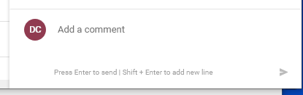

Setting a filter:
Click the Button on the upper left hand portion of the screen
Click the Button on the upper left hand portion of the screen
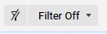

Next select new filter.
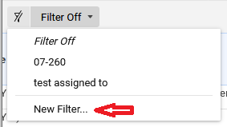

Give the filter a meaningful name, e.g. “STAUFFER I – CHEMISTRY”.
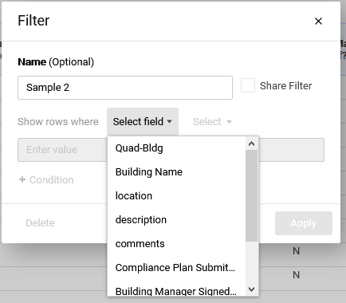
Next, click on the “+ Condition” button and choose a field. The screen will change and ask you to select a field.

The Quad-Bldg field and the “Assigned to” field as well as the “Building Manager Signed and the “SUFMO Signed” fields are chosen in this example.
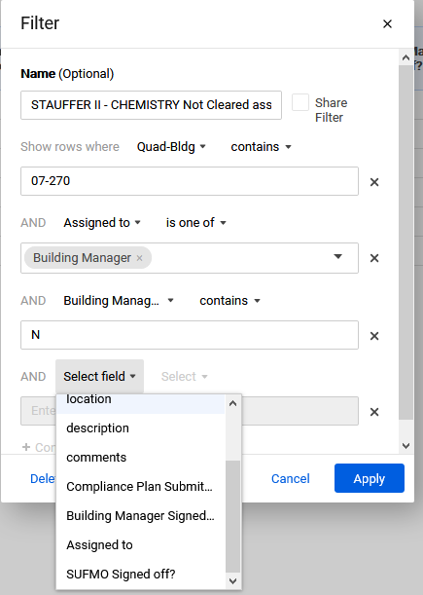

After choosing a field, select a condition from “Contains”, “Does Not Contain”, “is blank” or “is not blank”

After choosing a field and operator, enter the value e.g., “07-260” for the Quad-Bldg”.

Some fields are limited to specific values. The operators for this type of field are shown here.

If you choose “is one of”, select the values you want to filter for in the box as shown here;
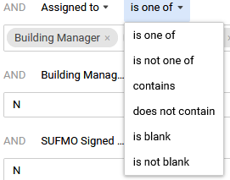
Add as many filter conditions as you want.
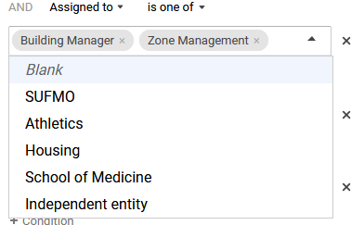

Some of the common filter configurations you may want are shown in the appendix.

Appendix
Common filters to save:
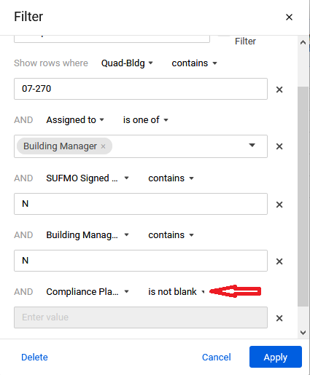
Shows items not cleared but a compliance plan has
been submitted been submitted
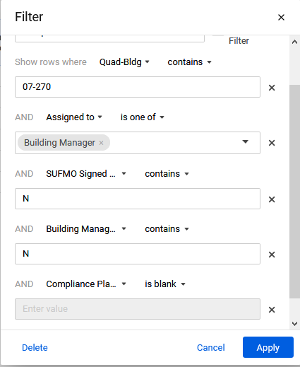
Shows items not cleared and no compliance plan submitted

