Welcome to the SmartSheet Fire Inspection tracking program.
For SUFMO inspectors

Overview
With this tool you will be able to:
- View the deficiencies noted in the fire inspection
- View who is the responsible parties particular items
- See if items are marked as complete by District or Building manager
- View photos and or other documents to a particular finding
- Approve a compliance plan.
- Track work order numbers
- Filter the list to see only those items you are interested in

Work Flow
- SUFMO will enter findings from the inspection into the SUFMO fire inspection database. Every night, item entered into the database will be uploaded and will be available to the “Fire Inspection Tracking System (District managers)”.

- District management will be notified by email that an inspection has been loaded. District management will log in and assign responsibilities to either Districts, Building Manager or SUFMO via “Fire Inspection Tracking System (District managers)” using the URL, sufmo.stanford.edu/inspection-tracking/District-managers
- The system will automatically notify the building managers and SUFMO about the items that are assigned to them.

- District management enters any work orders that were issued to address the item.

- The building manager will log in and set or open an existing filter to see what items have been assigned to them. A building manager may choose to see all deficiencies if they so desire.

- The building manager corrects deficiencies. Optionally, the building manager may record the date items were corrected.

- District issued work orders are completed. Optionally, the District manager may record the date items were corrected). If District Management enters a date in the field “Building Manager/District Manager Signoff date“, SUFMO will be automatically notified.

- SUFMO clears items where either building or District management have marked the item cleared by entering a date in the “Building Manager/District Manager Signoff date” and photos or comments or other documents are attached to the item.
  - District management may use the “Attachments (1)” link at the top of the form. Only the name of the file appears. The attachment can be viewed by clicking on the file icon in the “Details / Attachments” panel to download it. Attachments can also be viewed via the sheet “SUFMO Fire Inspection Findings”

- SUFMO will review the SmartSheet before the next inspection. Where the building manager or District Manager has signed off and provided photos or other documentation, the inspector may clear the item.

- SUFMO will re-inspect at the scheduled time and note and record in OneStep (SUFMO’s inspection database) items that have been cleared. The system will automatically update SmartSheet at the end of the day.

- SUFMO will schedule a subsequent inspection following SUFMO’s SOP if necessary, otherwise a report showing all items cleared will be issued.

Data can be exported from “LIST_ALL_FINDINGS (Integration)”. First set a filter, then click “File” (upper left on screen) then select “Export” and select the format to export to. In a filtered sheet, all rows are exported. The filtered rows are collapsed in the Excel sheet.

The following fields are filled out by the entities listed here:
- “Quad-Bldg” Filled in by the system
- ”Compliance Plan Inspection Due By” Filled in by District or Building manager
- ”Compliance Plan” Filled in by District or Building manager
- “Date Compliance Plan was requested” Filled in by District or Building manager Filled in by the system until it can be automated.
- “Compliance Plan Approved By” Filled in by SUFMO
- “Deficiency detail” Filled in by the system
- “Category” Filled in by SUFMO (Note, need to discuss, lot of work, some analytical benefit)
- “Compliance Plan Approved On” Filled in by the system
- “location“ System fills in
- “Assigned to” Filled in by District
- “Building Name“ System fills in
- “Building managers” System fills in
- “Work Order Number” Filled in by District
- “Building Manager/District Manager Signoff date“ Filled in by District
- “District Contact” System fills in
- “Violation description“, System fills in.
- “SUFMO Signoff date” Filled in by System via OneStep

Step by step:

Logging in
To log into “Fire Inspection Tracking System (SUFMO)” go to:
sufmo.stanford.edu/inspection-tracking/fire-inspectors
You will be asked to log in with a SmartSheet account with single sign on.

Grid view
You will be presented with a grid view of all the fire inspection items that you filtered for. You can set filters to see just the data you want, including viewing one building at a time (See “Setting a filter;” below).

Sorting
Sort by a single column by clicking of the column title.

Detail view and update panel
Click on a row to open a panel on the right side of the window where you can view details and enter data.
- Entering the data

Fields to update
Compliance Plan Approved By
Select your name from the dropdown
Category
Select as many as apply, this is to do analysis of what type of violations we are having. A toaster may have been cited under a few different codes depending on the inspector. This will provide a uniform grouping. Aaron and Marty must sign off on this.

All the other fields are read-only to be filled in by District managers, Building managers or the system.

Attaching documents
In the “Details” panel, at the top there is an “Attachments” link. Click on the link, then click the bar at the bottom of the pane, “Attach a File”. A browser window will open. Use that window to find and attach the file, picture, or other document (e.g., Plans or letters or Form 1 etc.)

Viewing attached documents
Click on the “Attachments” link at the top of the panel.
Click on the file you want to look at.
Check your Downloads folder.
Click on the document you just downloaded.
In some cases, simply double clicking on the file icon will open the file.
Adding comments:
In the “Details” panel, at the top there is a ”Comments“ link. Click the link and a dialog box will open at the bottom, “add a comment”. Type over the words “Add a comment”. When you are done, press Enter and the comment will be saved.
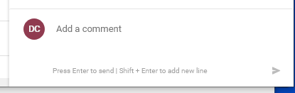

Setting a filter:
Click the Button on the upper left hand portion of the screen
Click the Button on the upper left hand portion of the screen
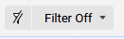

Next select new filter.
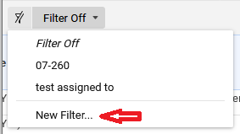

Give the filter a meaningful name, e.g., “STAUFFER I – CHEMISTRY”.
Next, click on the “+ Condition” button and choose a field. The screen will change and ask you to select a field.

The Quad-Bldg field and the “Assigned to” field as well as the “Building Manager Signed and the “SUFMO Signed” fields are chosen in this example.
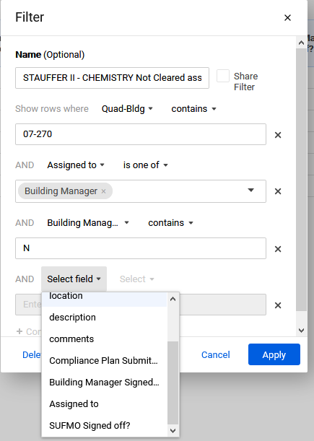

After choosing a field, select a condition from “Contains”, “Does Not Contain”, “is blank” or “is not blank”

After choosing a field and an operator, enter the value e.g., “07-260” for the Quad-Bldg”.

Some fields are limited to specific values. The operators for this type of field are shown here.

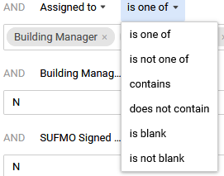
If you choose “is one of” and then select the values you want to filter for in the box as shown here;

Add as many filter conditions as you want.
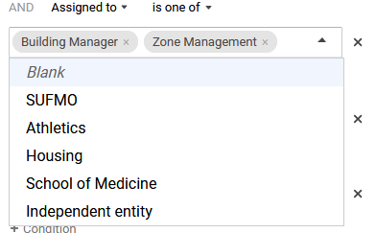

Some of the common filter configurations you may want are shown in the appendix.

Appendix
Common filters to save.
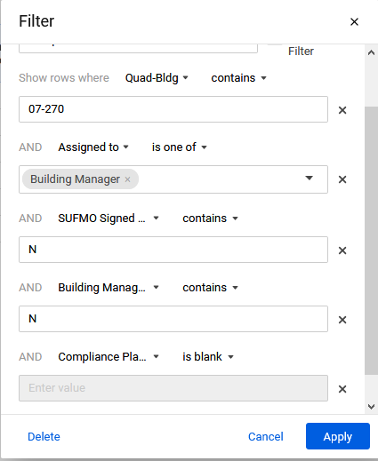
Shows items not cleared and no compliance plan submitted
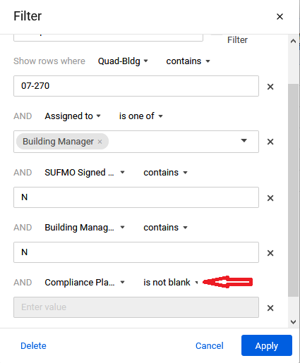
Shows items not cleared but a compliance plan has
been submitted been submitted

